
Link to access GitHub Repository: https://github.com/2026297-cyber/Strategic-Thinking

Assessment Cover Page
Student Full Name
Erick Henrique da Silva
Student Number
2026297
Module Title
Strategic Thinking
Assessment Title
Capstone Project - CA1
Lecturer/Supervisor
Taufique Ahmed
Assessment Due Date
25/10/2026
Date of Submission
18/10/2026
Use of AI Tools

I acknowledge the use of AI tools such as ChatGPT, Grammarly and Claude for the purpose of improving spelling and grammar, in addition to help to structure the work and to discuss several ideas, and also explaining machine learning concepts.

Declaration
By submitting this assessment, I confirm that I have read the CCT policy on academic misconduct and understand the implications of submitting work that is not my own or does not appropriately reference material taken from a third party or other source.
I declare it to be my own work and that all material from third parties has been appropriately referenced.
I further confirm that this work has not previously been submitted for assessment by myself or someone else in CCT College Dublin or any other higher education institution.

CONTENTS
Introduction........................................................................................................1
Problem Definition .............................................................................................1
Aim and Objectives.............................................................................................2
Scope ..................................................................................................................2
Methodology ......................................................................................................2
Data Sources ......................................................................................................3
Expected Deliverables ........................................................................................4
Project Timeline .................................................................................................4
Ethical and Legal Considerations .......................................................................5
References .........................................................................................................6
Appendix ............................................................................................................7

Predicting Premier League match outcomes to maximize investment in football team sponsorships: a cost-benefit perspective

Introduction

One of the most common ways for companies to gain visibility within specific segments of society and consequently increase their revenue is through sponsorship investments. In this context, one of the most frequent and high-value forms of investment is sponsoring football teams. Given the very large sums of money that English Football generates each season, this project aims to develop a predictive model to analyse Premier League matches. Therefore, provide support to potential sponsors looking to make a good and informed decisions.

Problem Definition

When investors look for teams to finance or sponsor, they must evaluate several criteria before making a final decision. If the investor choose to invest in the most famous team in Premier League this investor probably would have extremely high costs, but on the other hand, an investor who does not make very clear criteria and conduct a rigorous analysis of a potential team's risks can make a significant mistake, for example, joining a team that is in a sharp decline. In this context, Connell (2025b) explains that some sponsors make good deals, while others are paying more than necessary. Therefore, the problem to be addressed is to identify the teams that offer the best possible cost-benefit ratio, allowing investors to effectively display their brands on the football team’s uniforms. “While factors like reputation, brand alignment, and community values are increasingly important to sponsors, one priority continues to dominate in Premier League partnerships: exposure (Connell, 2025a)”.

Aim and Objectives

The Primary Objective of this study is building a predictive model applying in Premier League matches to identify teams that offer the best “cost-benefit” ratio for investment purposes. To achieve this goal, these steps will be followed:
- Analyse the most new Premier League seasons, probably last 10 years, to identify patterns within the collected data.
- Develop and estimate models designed to predict probabilities of a win, draw or loss for each team.
- Calculate the probability of each team advancing in the league to determine the probability of each team becoming champion.
- Determine a relation between championship probabilities and the sponsor value of each team to calculate a cost-benefit indicator.

Scope

This Study covers data from the last 10 years, specifically the 10 most recent Premier League seasons, and each season has 20 teams, resulting in a total of 34 different football teams analysed. Approximately 3800 matches in total. The dataset includes 22 columns, such as match date, team names, home/away matches, number of goals, fouls, and cards. For simulating seasons and games, Machine Learning techniques, including modelling and classification, are used. These results will be compared with public sponsorship values. The scope excludes individual player analysis, competitions that are not the Premier League, injuries and player negotiations.

Methodology

The project will be realized in python programming with Jupyter Notebook, and using libraries like Pandas, Matplotlib, and Scikit-learn. First of all is essential clean the data to remove any error, after is necessary organize the data to be easier read and interpretate this data. New variables will be created based on combinations of goals scored and the difference between home and away matches. After that, machine learning models will be compared, like logistic regression, random forest, and KNN, to check which one can be applied better. Earlier matches and season will be used for model training, and recent matches and seasons will be used for testing.
The study will identify the indicators of winning the championship, which will be compared with data of sponsorship costs, to determine the cost-benefit ratio of investments.

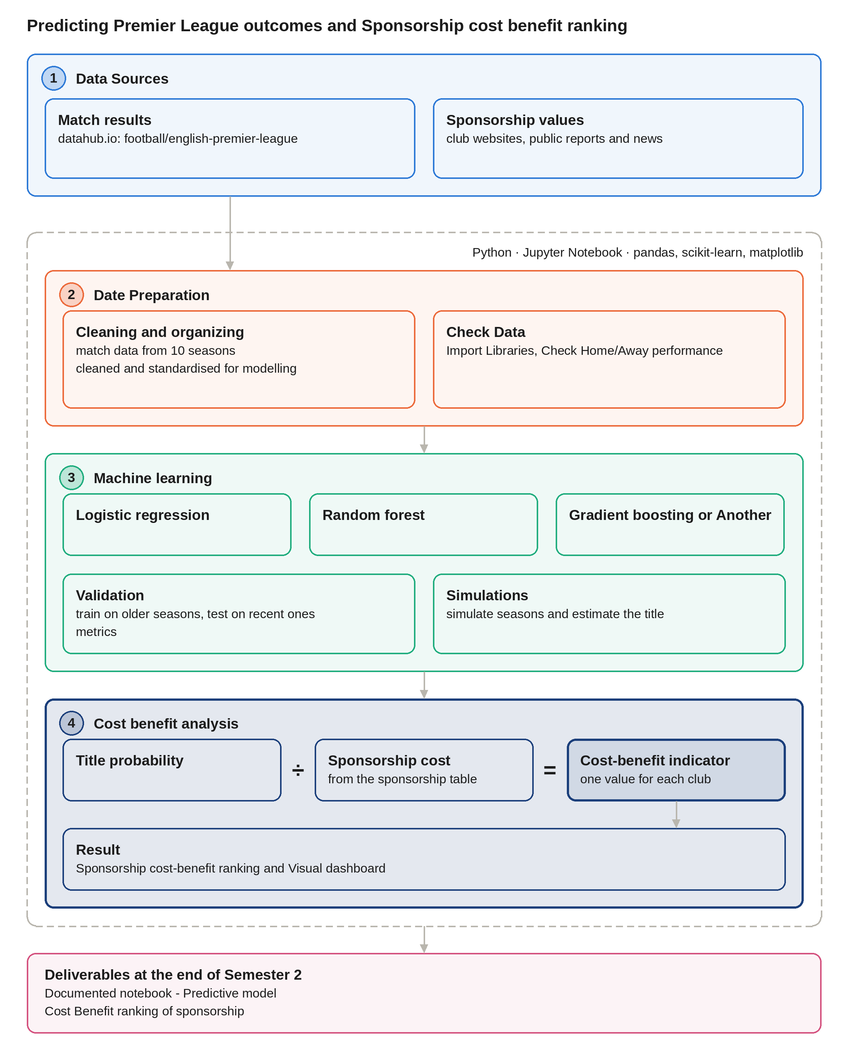

Data Sources

All data was obtained from the website datahub.io and consists in a collection of 10 separate datasets, relating to the last 10 Premier League Seasons. The total number of football matches is 3800, with approximately 22 columns available for analysis. With 20 teams competing in the league each season, a total of 34 distinct teams were analysed for having competed in the Premier League at least once in the last 10 years.
Information about sponsorship values was founded on The Sponsor, a largely recognized platform for data on sponsorship in the European Market. Both websites are public and all information is available online.
- datahub.io/football/english-premier-league -
- thesponsor.com/revealed-premier-league-fair-market-sponsorship-values-2025/
- thesponsor.com/premier-league-fair-market-sponsorship-values-full-table-and-year-on-year-results/

Expected Deliverables

The final project will include an analysis performed using the final data; and a predictive model with an accuracy level considered reliable noted that football is an uncertain sport and it only depends on human interactions and based on constant variations. Consequently, it is not possible to achieve a predictive model with extremely high precision rates, “and in the best predictions the accuracy is always approximately 55%” (Ren and Susnjak, 2022); a ranking of the cost-benefit ratio investments; a dashboard showing the key results achieved and relevant support documentation, probably limitations and final conclusions.

Project Timeline

In the first semester the problem has to be defined; collect the properly data and after that the data need to be analysed. This phase includes data cleaning and preliminary analysis. At the end of the first semester, variables will be created and an initial model developed. In the second semester, the focus will be in organizing, analysing and comparing different models, running simulations and incorporating cost-benefit indicators.

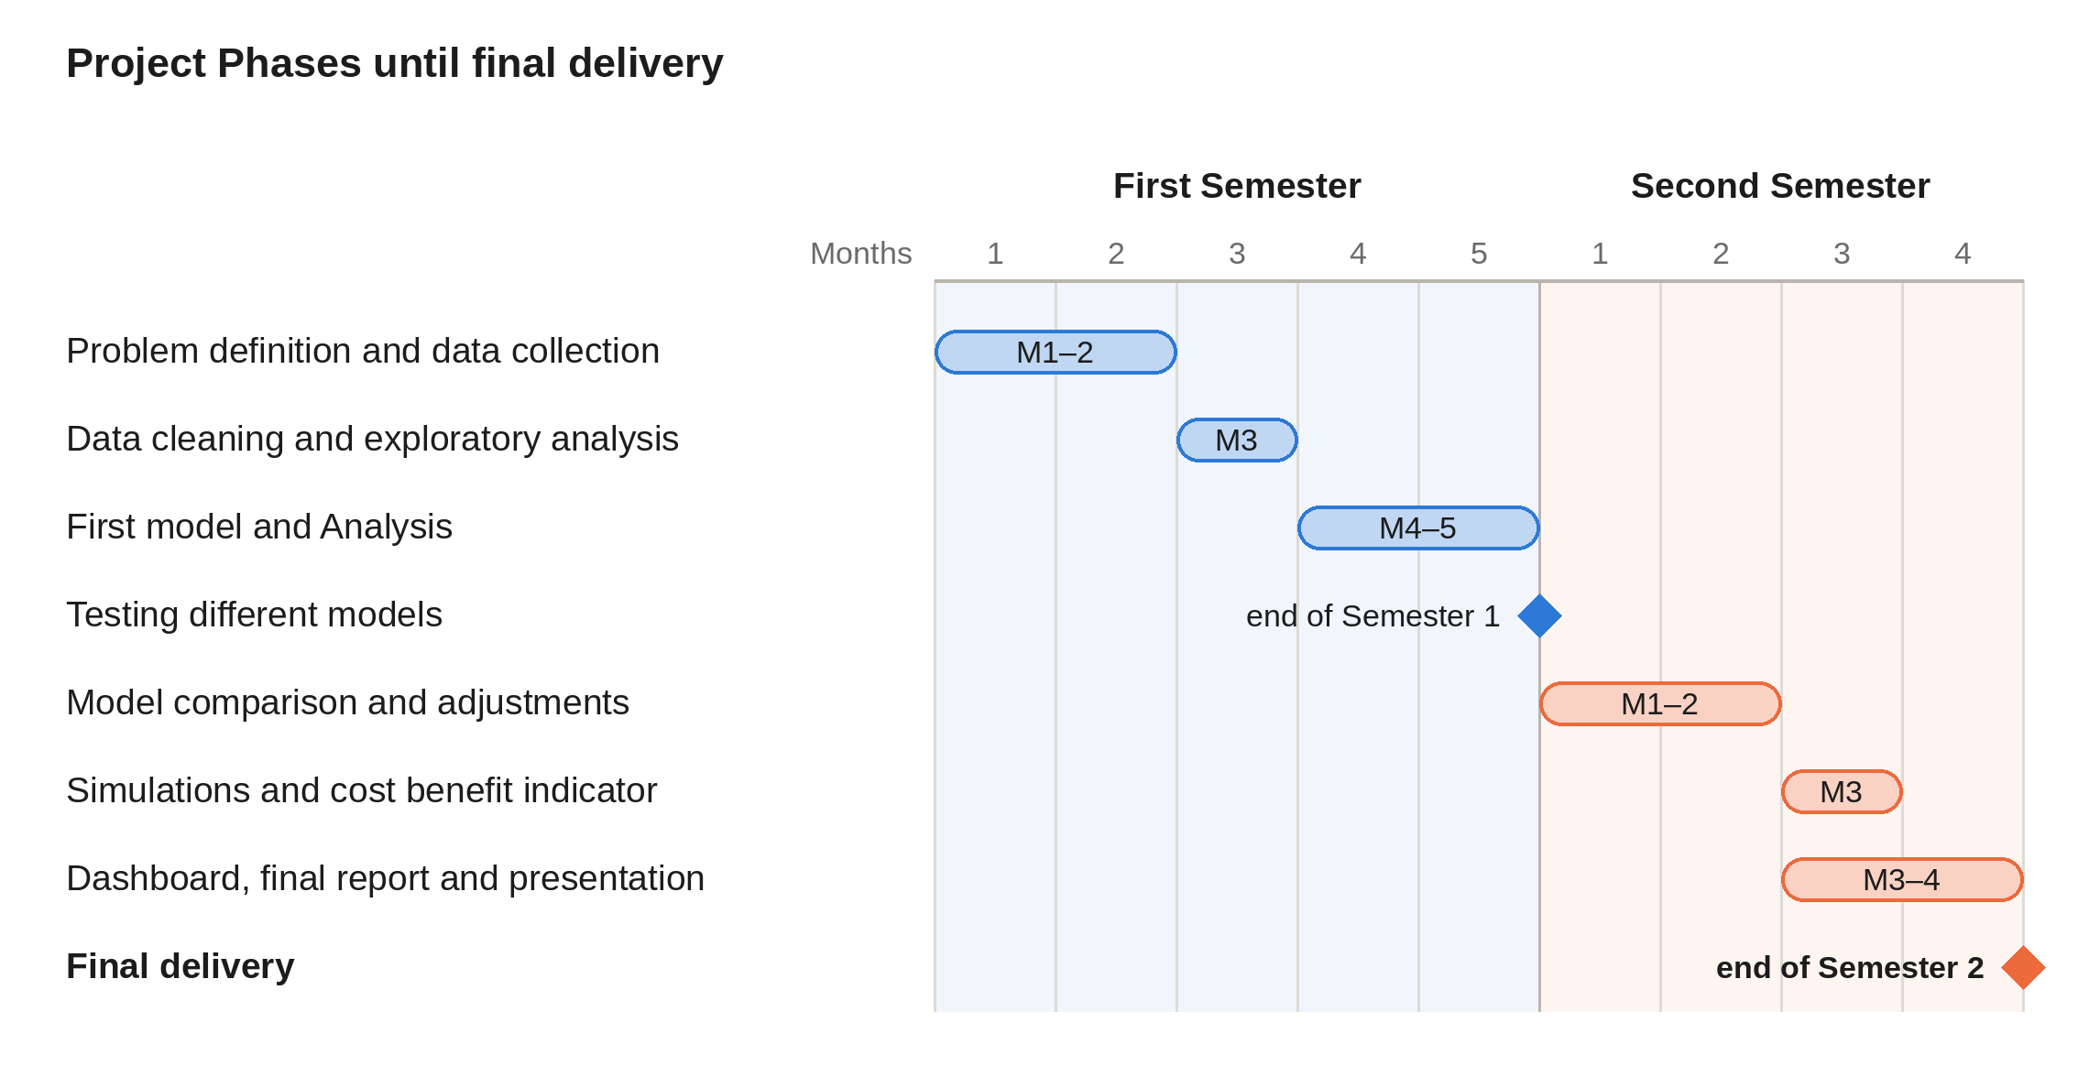

Ethical and Legal Considerations

In compliance with the GDPR, all data regarding football matches are public and do not contain sensitive information that could interfere with an individual's personal life. Therefore, there are no privacy risks. In a similar way, all information about team sponsorship is public and published in the media, and all sources used are properly cited. From an ethical Standpoint.

References

Connell, S. (2025a) ‘Premier League fair market sponsorship values: Full table and year-on-year results’, The Sponsor, 2 June. Available at: https://www.thesponsor.com/premier-league-fair-market-sponsorship-values-full-table-and-year-on-year-results/ (Accessed: 18 October 2026).
Connell, S. (2025b) ‘Revealed: Premier League Fair Market Sponsorship Values 2025’, The Sponsor, 2 June. Available at: https://www.thesponsor.com/revealed-premier-league-fair-market-sponsorship-values-2025/ (Accessed: 11 October 2026).
DATAHUB (n.d.) English Premier League (Football). Available at: https://datahub.io/football/english-premier-league (Accessed: 10 October 2026).
Ren, Y. and Susnjak, T. (2022) ‘Predicting Football Match Outcomes with eXplainable Machine Learning and the Kelly Index’. arXiv: 2211.15734. Available at: https://arxiv.org/pdf/2211.15734 (Accessed: 15 October 2026).

Appendix

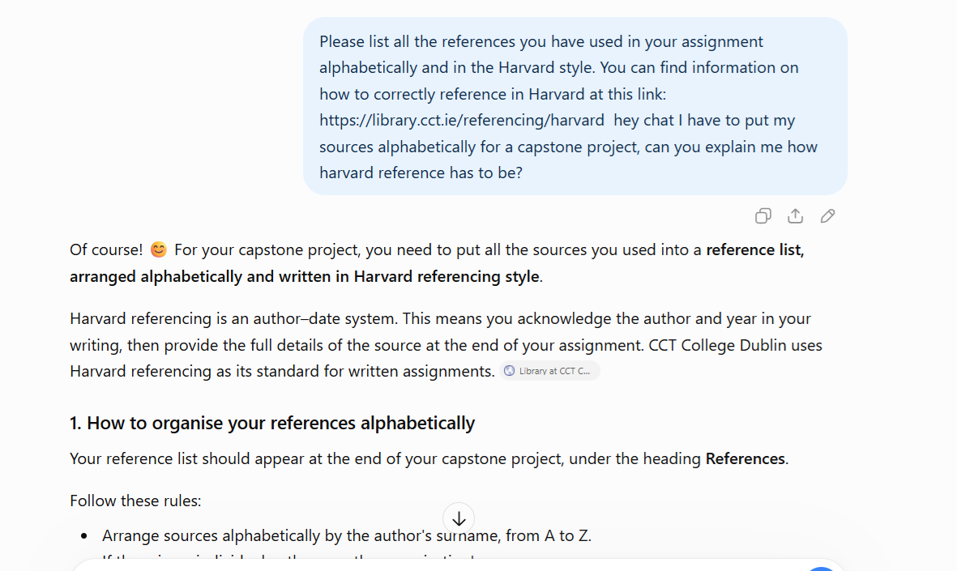

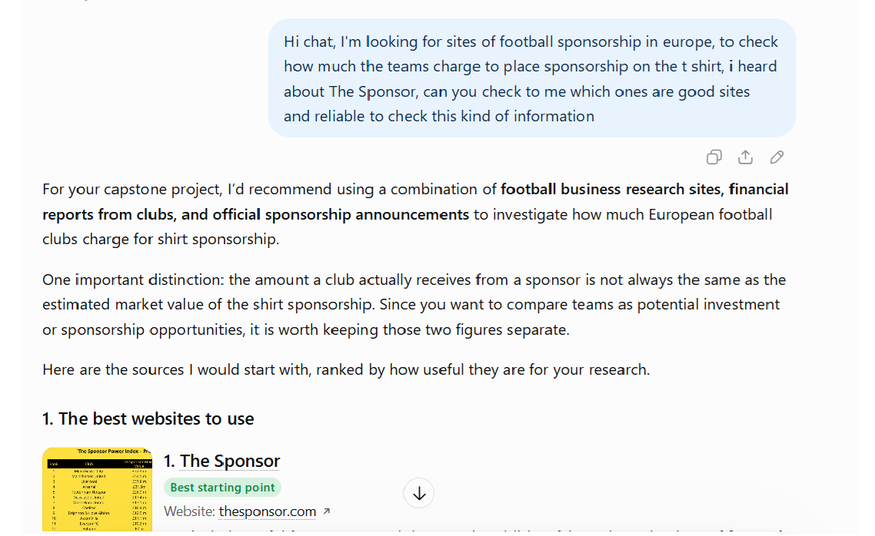

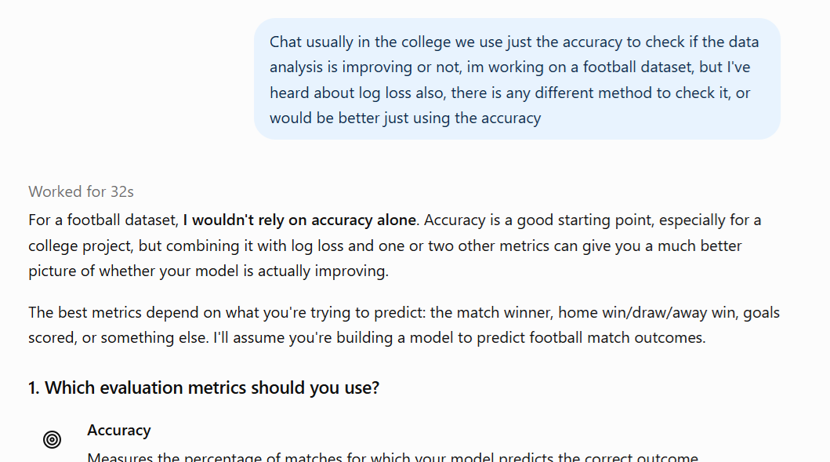

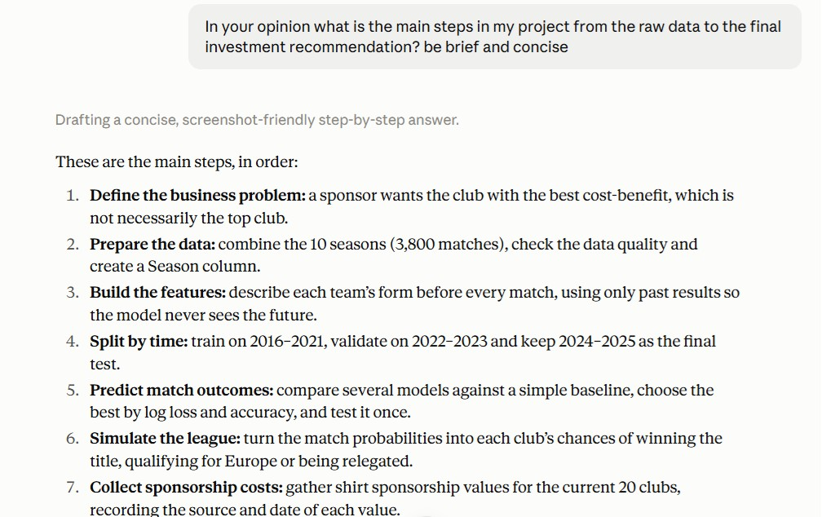
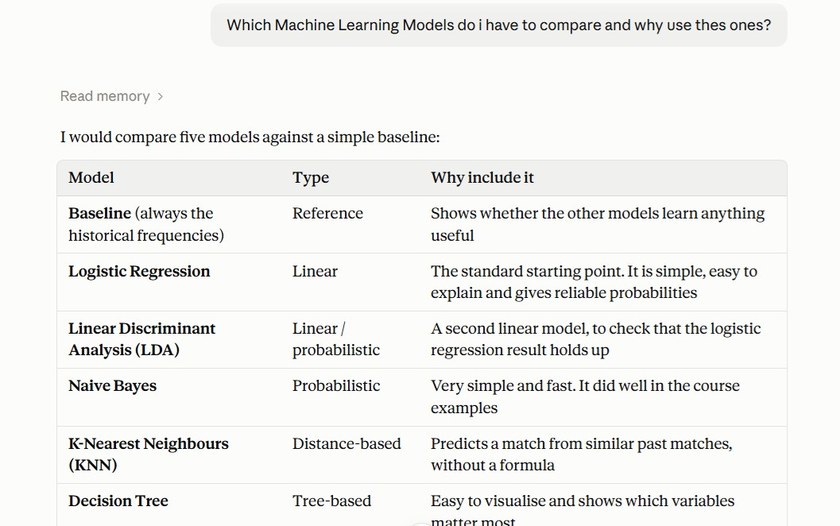

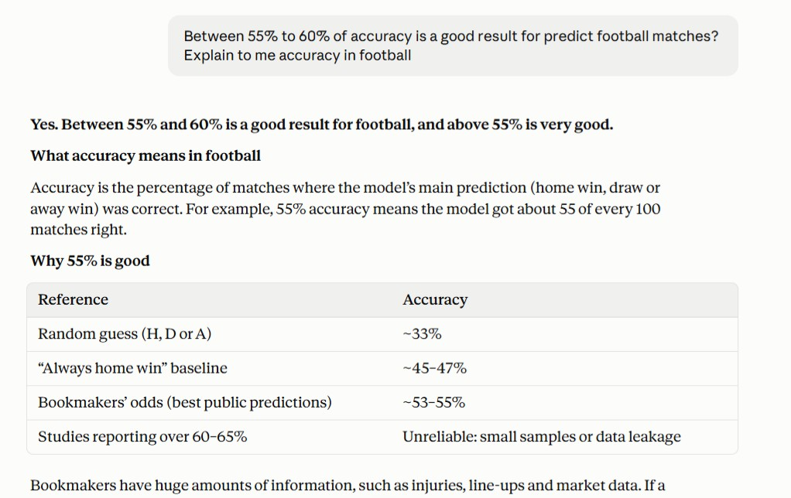

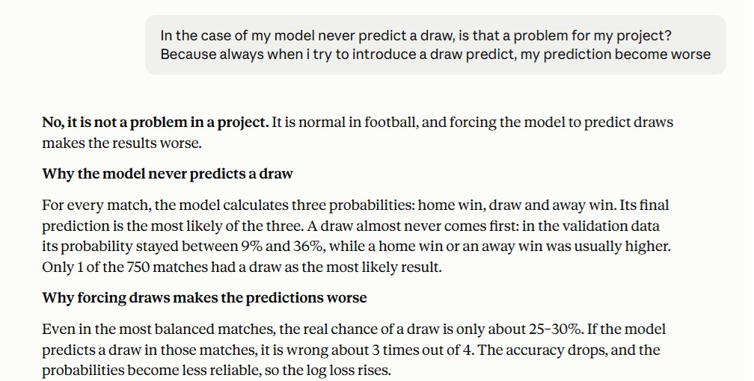

AI competence | Reflective prompts (to students) | Lecturer expectations | Student response
Delegation  Deciding whether & when to use AI | Identify the specific tasks in this assessment where you chose to use AI, and explain your reasoning. Where did AI add value? Where did you decide not to use it, and why? | You may use AI to support your learning and development of the application. Clearly identify where you used AI and where you completed the work independently. | For while, I used it just to explain Harvard references to me and check whether datasets and websites are reliable.
Description  How you prompted the AI | Include the exact prompts you used in your appendix (recorded on the AI Tools declaration). Reflect on how you communicated your goals to the AI — did you need to iterate or refine your prompts to get useful output? | You must provide the exact prompts and relevant AI outputs used during the development of your application. | Printed image on top.
Discernment  Evaluating what the AI produced | In your reflection, critically evaluate the AI output: what did you accept, modify, or reject — and why? Assess accuracy, relevance, and quality. You are responsible for verifying all AI-generated content before submitting. | You are responsible for checking, testing and understanding any AI-generated code or suggestions before using them in your work. | It was used just to confirm ideas previously known.
Diligence  Responsibility for your AI use | Declare all AI tools used and cite them here. Briefly outline how you considered data protection, copyright, and ethical responsibilities when choosing what to input into any AI system. Unauthorised use is subject to CCT disciplinary procedures. | Declare all AI tools used. Do not enter personal, confidential or sensitive information into AI tools. Any external sources used should be appropriately referenced. | I usually use ChatGPT and Grammarly. I open the result and resources to check.

